**DAILY ONLINE ACTIVITIES SUMMARY**

|  |  |  |  |
| --- | --- | --- | --- |
| **Date:** | 3/06/2020 | **Name:** | Krishnitha |
| **Sem & Sec** | 4th sem, A Section | **USN:** | 4AL18CS039 |
| **Online Test Summary** | | | |
| **Subject** | Object Oriented Concepts | | |
| **Max. Marks** | 30 | **Score** | 19 |
| **Certification Course Summary** | | | |
| **Course** | Python for Machine Learning | | |
| **Certificate Provider** | Great Learning | **Duration:** | 4hrs |
| **Coding Challenges** | | | |
| **Problem Statement:**  1) Write a code segment in java to swap two numbers using call by object reference.  2) Write a Java program to find Last Digit of a^b (a to the power b) for Large Numbers  3) Write a function that takes a two-digit number and determines if it’s the largest of two possible digit swaps. | | | |
| **Status:** Executed | | | |
| **Uploaded the report in GitHub** | | YES | |
| **If yes Repository name** | | <https://github.com/krishnitha/C-coding>  <https://github.com/krishnitha/Java-coding> | |
| **Uploaded the report in slack** | | YES | |

**Online Test Details:**

Today we had assessment in the subject Object-Oriented Concepts. The test was based on second and third module of this subject. There were total 30 number of questions of ONE mark each, out of which I scored 19.

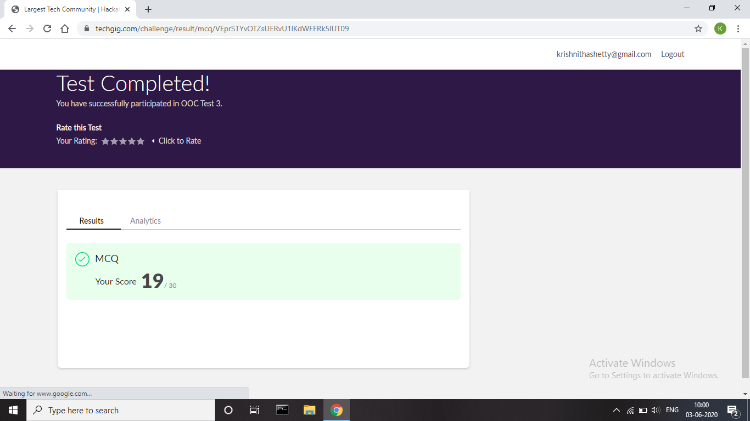

**Certification Course Details:**

Today I have done certification course on Python for Machine Learning Couse by Great learning. Today I learn about Jupyter notebook shortcuts, Data structures hands on, looping and conditional statements and Introduction to pandas and about series and data frames in pandas. Also, I learnt about accessing and modifying, combining data frames in pandas.

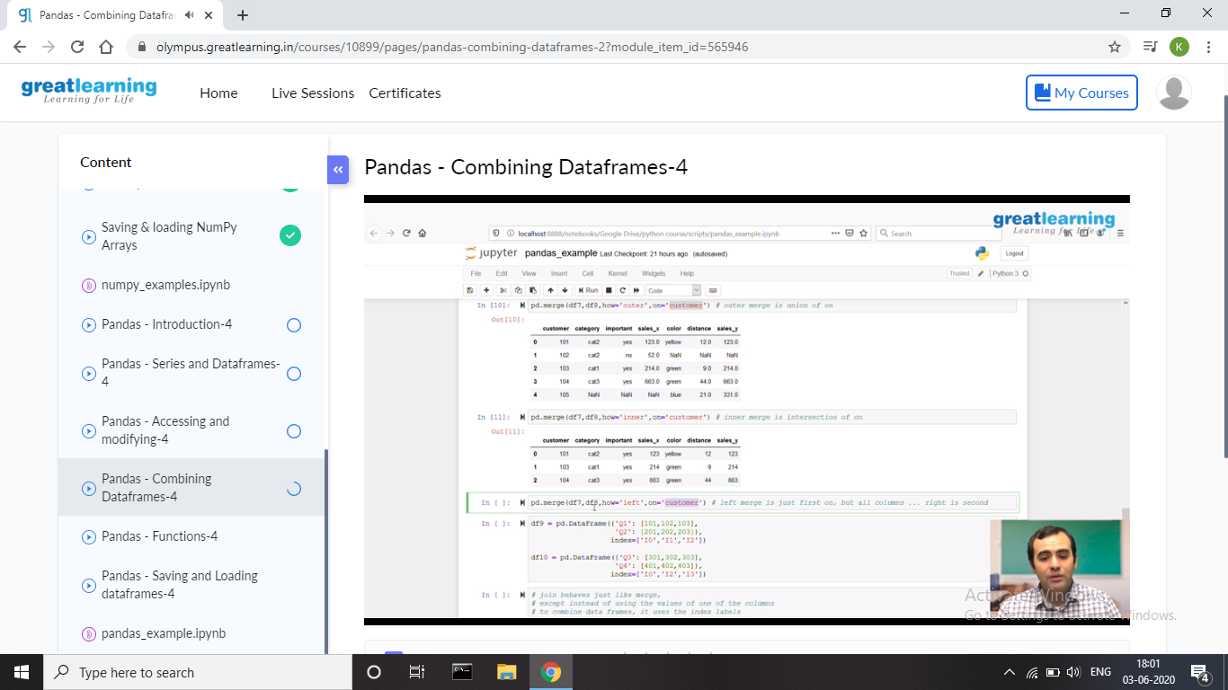

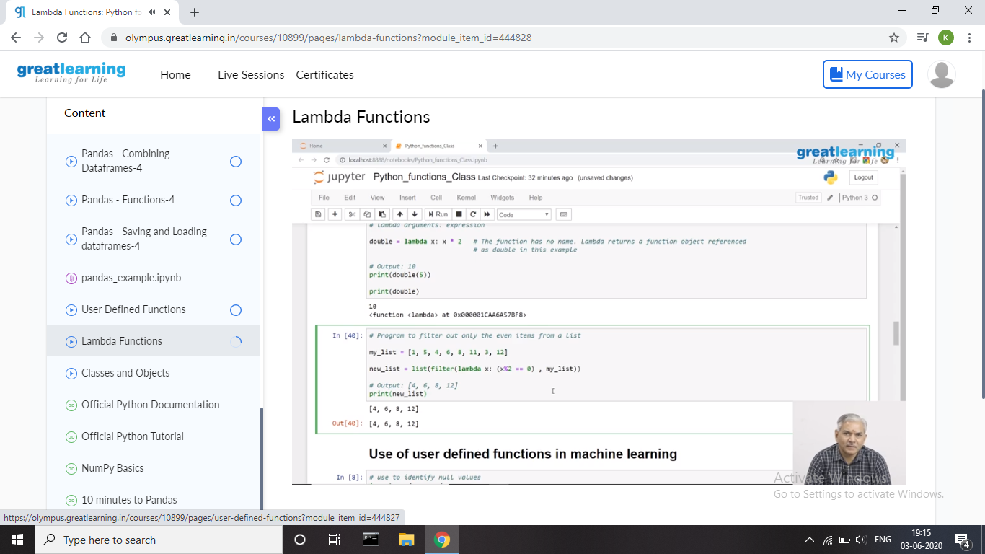

Coding Challenges Details:

**Problem 1:** Write a code segment in java to swap two numbers using call by object reference.

**Solution:** Uploaded it in GitHub

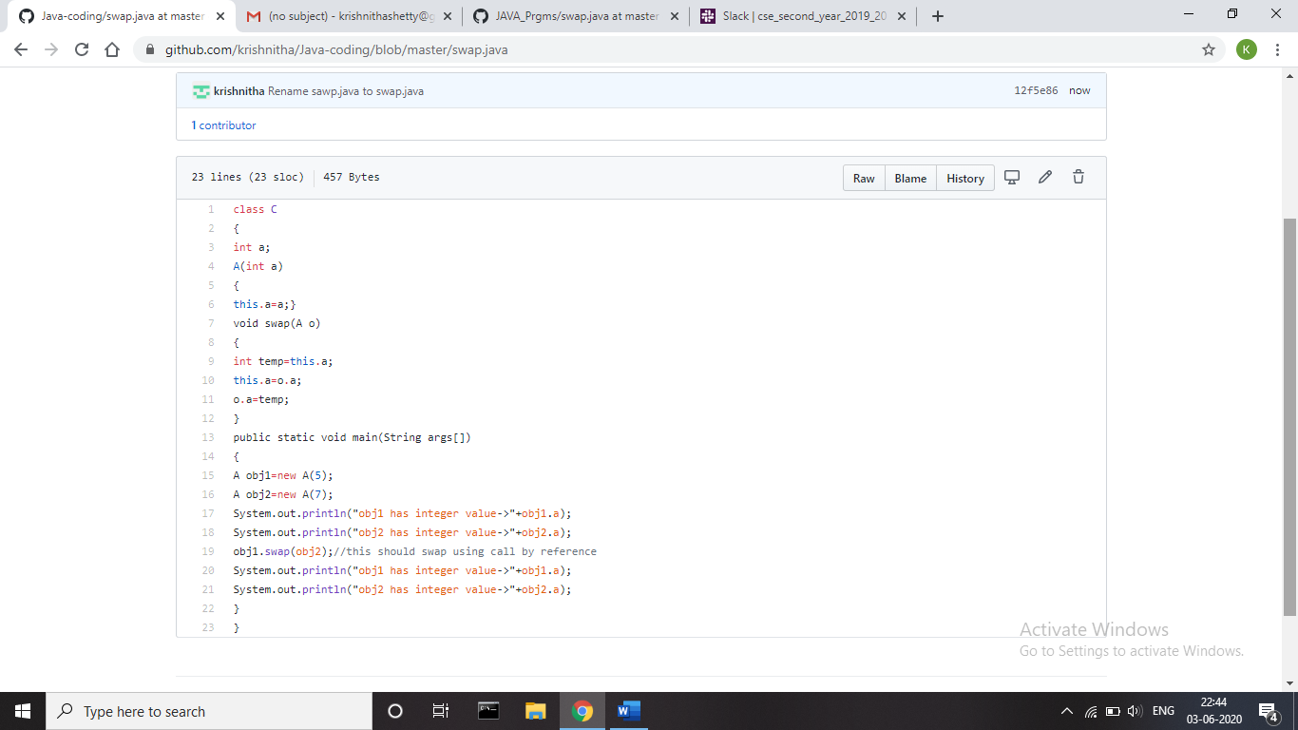

**Problem 2:** You are given two integer numbers, the base a (number of digits d, such that 1 <= d <= 1000) and the index b (0 <= b <= 922*10^15). You have to find the last digit of a^b.

**Examples:**

Input : 3 10  
Output : 9

Input : 6 2  
Output : 6

Algorithm  
Algorithm :

1. Since number are very large we store them as a string.
2. Take last digit in base a.
3. Now calculate b%4. Here b is very large.

-> If b%4==0 that means b is completely divisible by 4, so our exponent now will be exp = 4  
because by multiplying number 4 times, we get the last digit according to cycle table in  
above diagram.  
->If b%4!=0 that means b is not completely divisible by 4, so our exponent now will be  
exp=b%4 because by multiplying number exponent times, we get the last digit according to  
cycle table in above diagram.  
-> Now calculate digit = pow( last_digit_in_base, exp ).  
->Last digit of a^b will be ldigit%10.

**Solution:** Uploaded it in GitHub

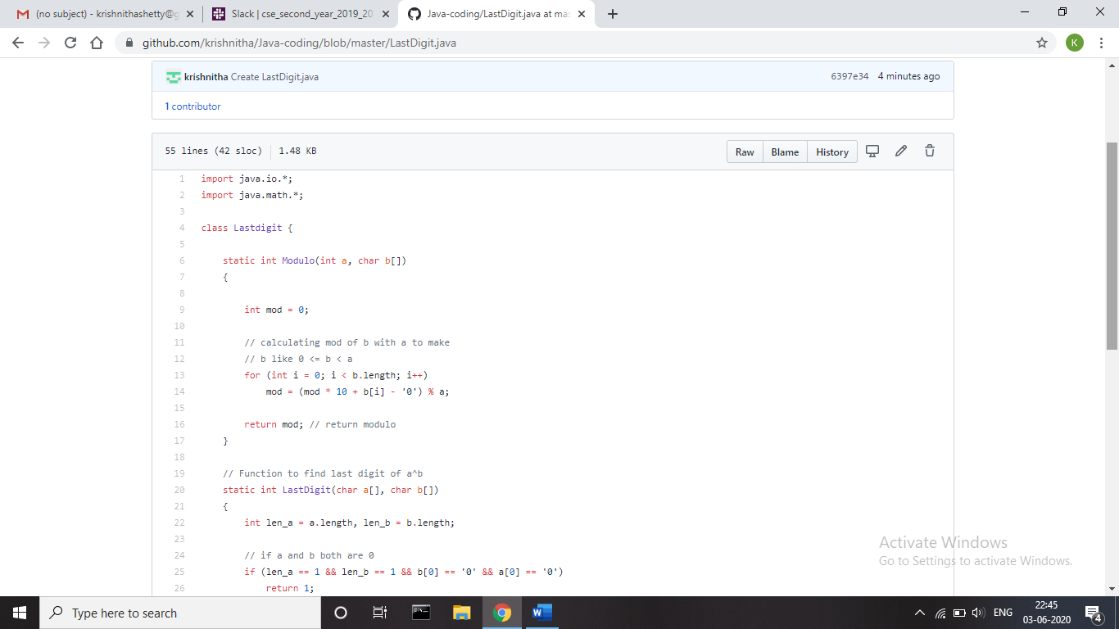

**Problem 3:** Write a function that takes a two-digit number and determines if it's the largest of two possible digit swaps.

To illustrate: largestSwap(27) ➞ false largestSwap(43) ➞ true If 27 is our input, we should return false because swapping the digits gives us 72, and 72 > 27. On the other hand, swapping 43 gives us 34, and 43 > 34. Examples largestSwap(14) ➞ false largestSwap(53) ➞ true largestSwap(99) ➞ true

**Solution:** Uploaded it in GitHub

